**Assignment 03**

**Note : To solve below queries use “hr” database**

1. Write a query to get unique department ID from employee table.

**select distinct DEPARTMENT_ID from employees;**

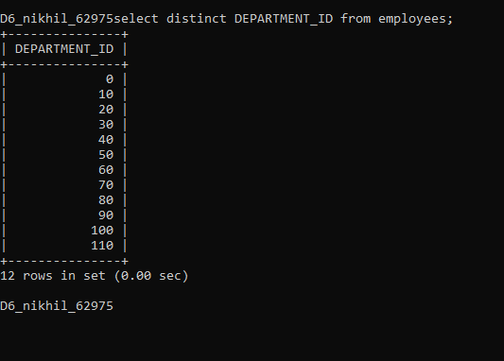

**End.**

1. Write a query to get all employee details from the employee table order by first name, descending.

**select * from employees order by first_name desc;**

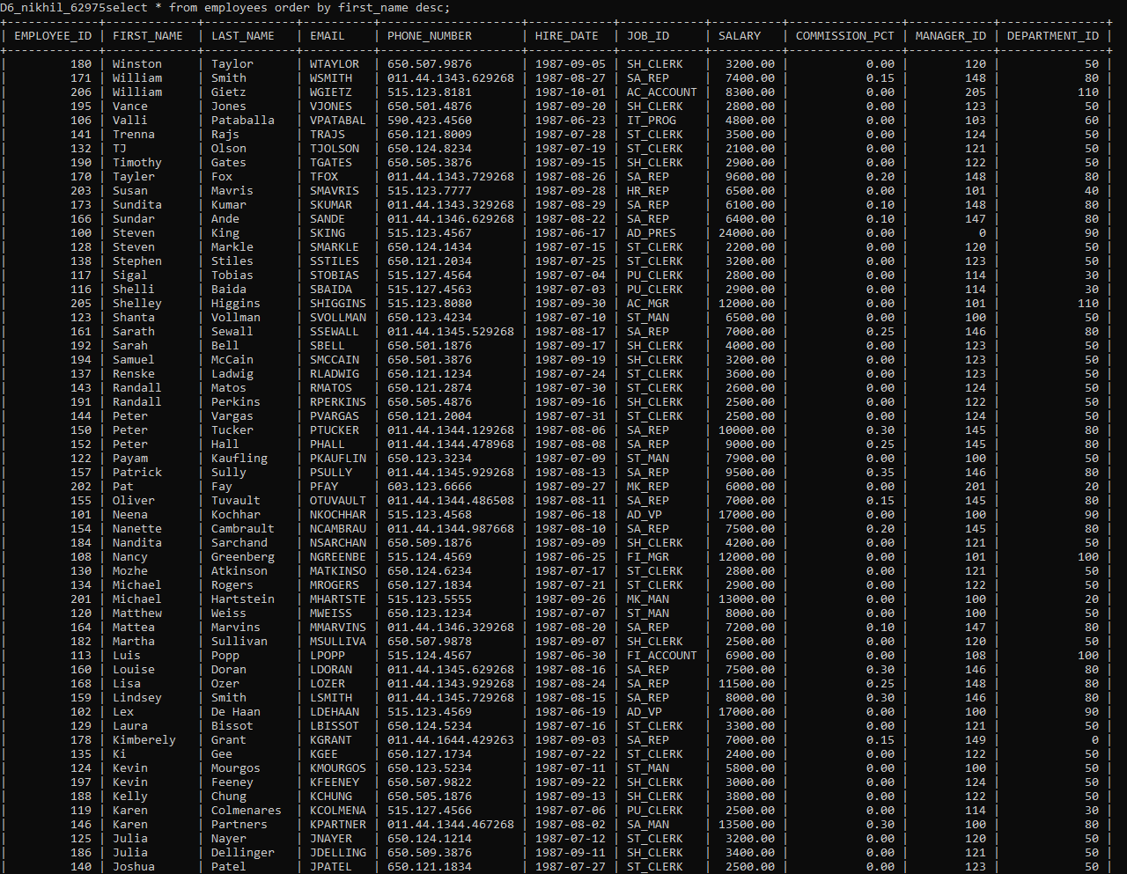

End.

1. Write a query to get the employee ID, names (first_name, last_name), salary in ascending order of salary.

**select EMPLOYEE_ID, FIRST_NAME,LAST_NAME, SALARY from employees order by salary;**

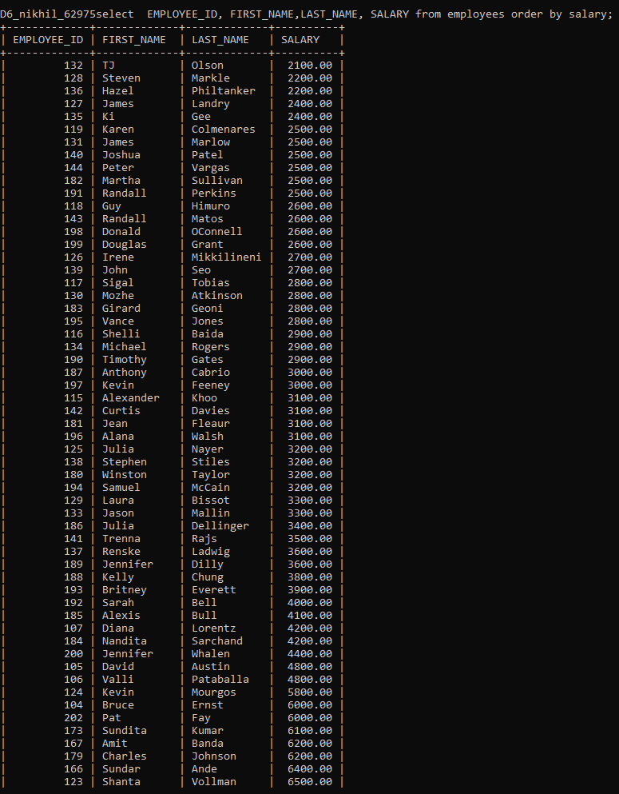

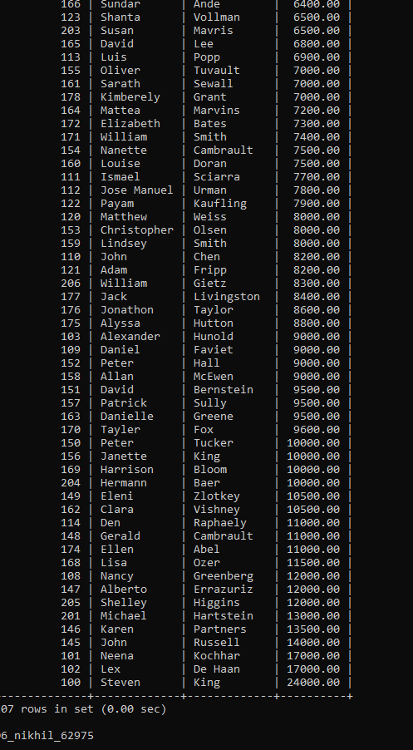

1. Display first name and join date of the employees who is either IT Programmer or Sales Man.

**select first_name,hire_date from employees where JOB_ID in ('IT_PROG','SA_MAN');**

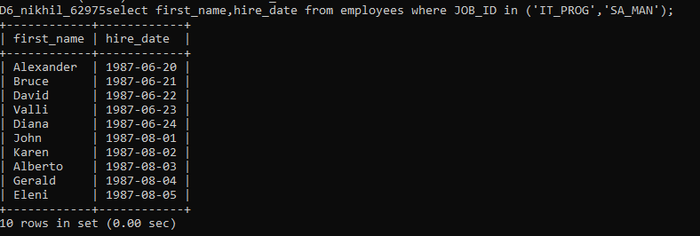

**End.**

1. Display details of employee with ID 150 or 160.

**select * from employees where EMPLOYEE_ID in(150,160);**

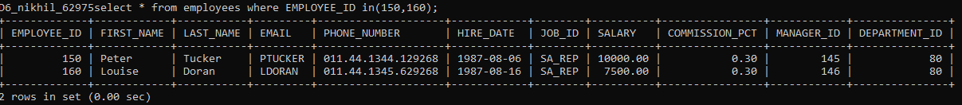

**End.**

1. Display first name, salary, commission pct, and hire date for employees with salary less than 10000.

**select FIRST_NAME,salary,HIRE_DATE,COMMISSION_PCT from employees where salary<10000;**

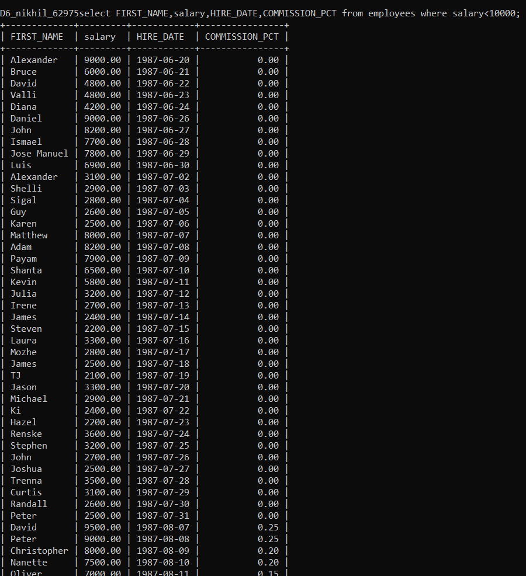

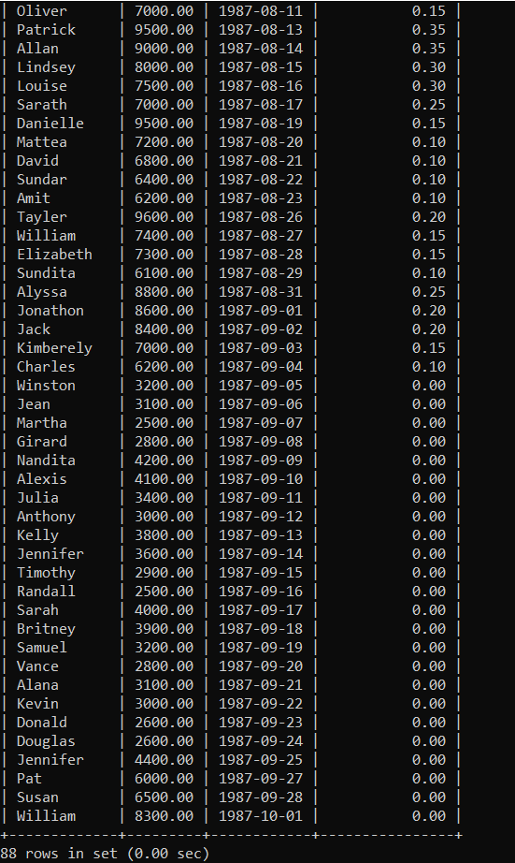

1. Display employees where the first name or last name starts with S.

**select * from employees where first_name like 'S%' or last_name like 'S%';**

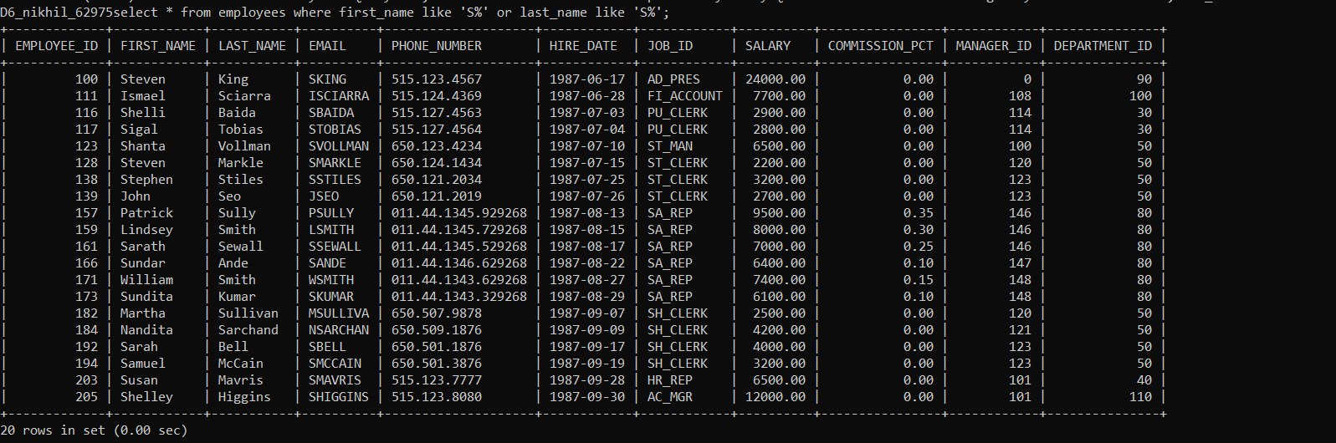

1. Display details of jobs in the descending order of the title.

**select job_title from jobs order by job_title;**

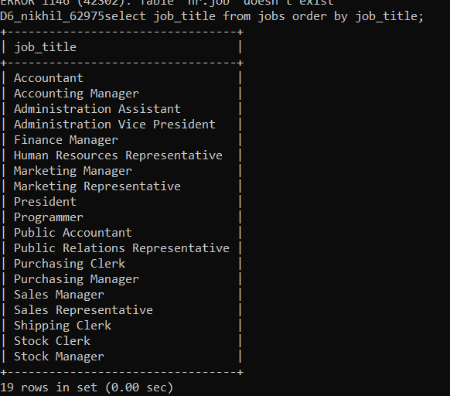

1. Display details of the employees where commission percentage is null and salary in the range 5000 to 10000 and department is 30.

**select * from employees where COMMISSION_PCT <=> null and salary between 5000 and 10000 or department_id=30;**

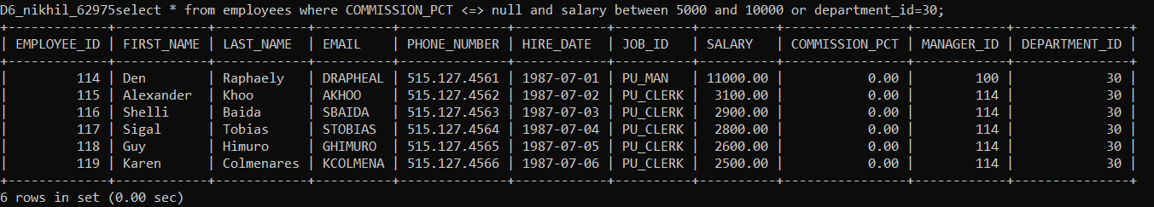

1. Display employees first_name,email who are working in “Executive” department.

**select first_name,email from employees where department_id=90;**

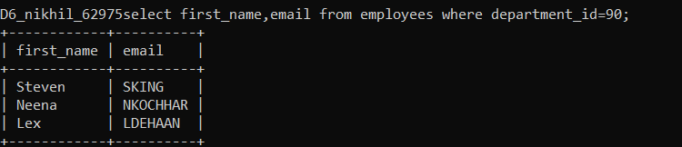

1. Display unique contry_id from locations table.

**select distinct COUNTRY_ID from locations;**

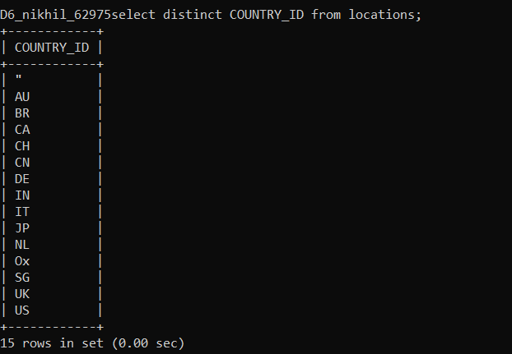

12. Display all employees whose have job_id IT_PROG and

FI_ACCOUNT.

**select * from employees where job_id='IT_PROG' or job_id='FI_ACCOUNT';**

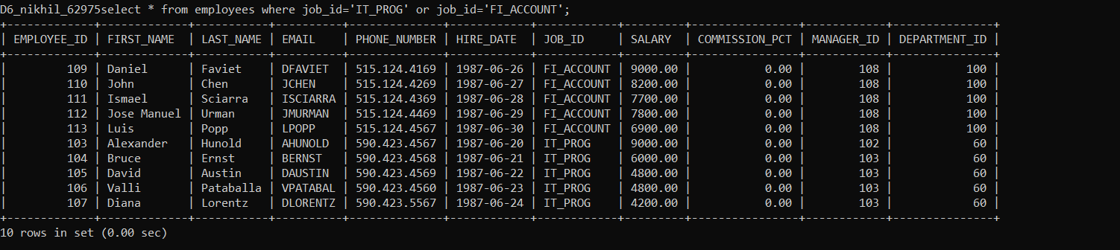

13. Display all countries in ascending order

**select * from countries order by country_name;**

